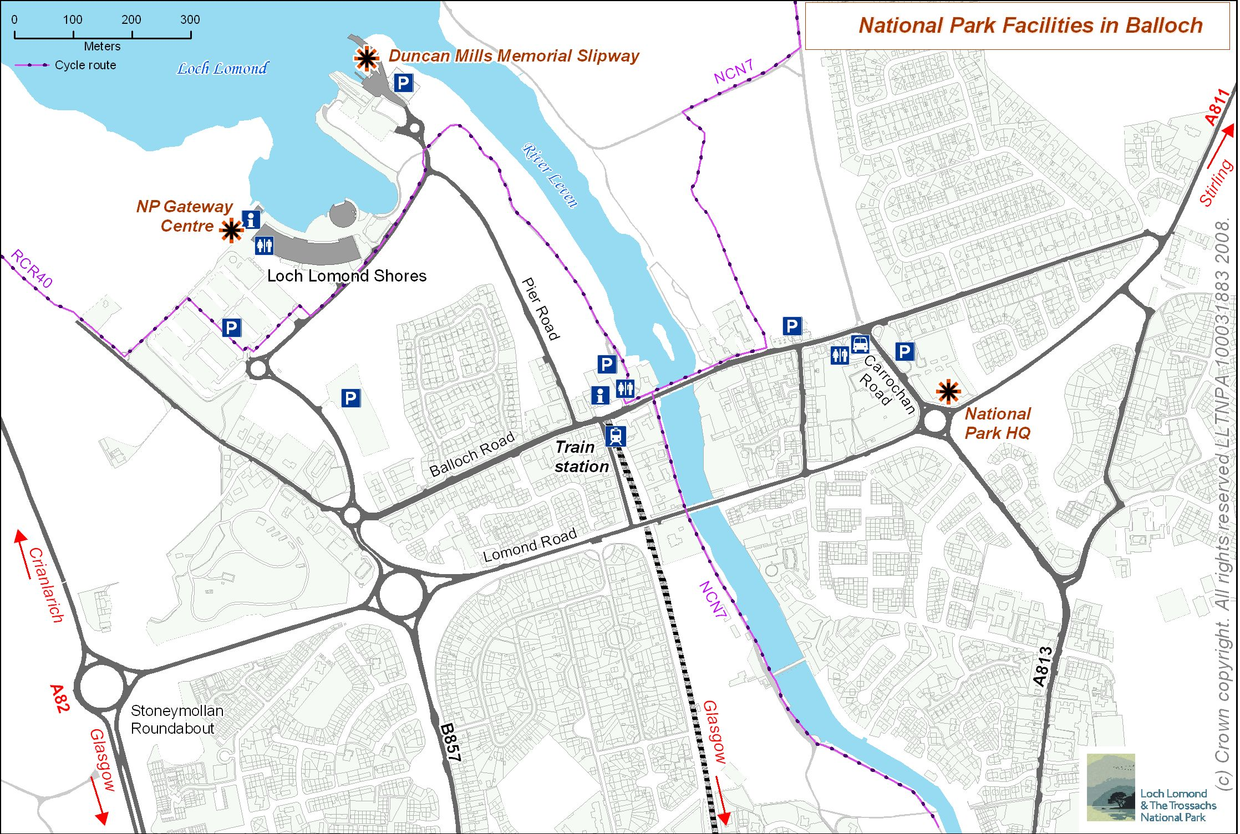

Travel Directions

Train
A half hourly service operates from Glasgow to Balloch Station. It is a pleasant 5 minute walk from the station to the HQ. Turn right on exiting the station. Go over the bridge and walk past shops turning right at the bus terminus, the HQ is on the opposite side of the road.

Cycle
Secure cycle facilties are available at the building. National Cycle Route 7 passes close by.

Bus
There are frequent local services between Alexandria and Helensburgh. Connections to Drymen and Balfron are less frequent. Most of these services stop at the bus terminus opposite the HQ. See “Exploring the National Park by ferry, bus or train” for more details or contact traveline. http://www.traveline.org.uk/index.htm

Car
If you have to travel by car free parking is available next to the building. Where possible we encourage car sharing. Your meeting organiser will be happy, where appropriate, to share details of others attending meetings so that lifts can be organised.
- From Glasgow, Edinburgh and the south take the M8 to Junction 30 then M898 continue on A898 signposted Erskine Bridge. Branch left merging into the A82 signposted Crainlarich. Leave the A82 turning right at the Stoneymollan roundabout, straight on at next roundabout then left at the next roundabout, building and car park immediately on the right. Travel time from central Glasgow approximately 40 Minutes.
- From the North (west side Loch Lomond) A82 turn left at the Stoneymollan roundabout then as above.
- From the East (East side Loch Lomond), Stirling take A811 to Balloch. Stay on A811 - do not take turn into village, at first round-a-bout in Balloch turn right and building and car park are immediately on the right. Time from Stirling 50 minutes.

